|  |
| --- |
| **The Best Type of Advertising** |
| “As Seen Advertised” Company |
|  |

**BIA – 660, Spring 2013**

Frank Consentino

Jennifer Meidl

Qi Zhu

# Introduction

For the purposes of this presentation we represent a hypothetical company “As Seen Advertised”. Our corporate executives are debating which advertising method would be the most effective for an upcoming advertising campaign. The campaign’s focus is to increase brand awareness and, of course, market share. Our task is to outline and analyze the existing options and provide a convincing report which will point management to the best option based on our findings.

# Analysis

In this analysis we want to gauge public perception of advertisements viewed via broadcast television, the Super Bowl and on the web. We have selected three advertisements per method. Sentiment for each advertisement will be compared and contrasted to the others within its respective method. Subsequently, each method will be compared against the others to determine which method is best. Below are the advertisements we have chosen to analyze.

|  |  |  |
| --- | --- | --- |
| Super Bowl | TV Broadcasting | VIRAL |
| Coca-Cola  Sleep Walk Man | Microsoft  Surface Pro | Old Spice  The man your man could smell like |
| Doritos  Casket | IKEA  Not Available | Will it blend  Not Available |
| E*Trade  Not Available | Nestle  KitKat Squirrel | Evian:  Roller Babies |

# Sources

It was decided to extract data from two sources in order to gain an overall pulse for the sentiment analysis. YouTube.com was used to obtain comments on the actual video advertisements and Topsy.com was used to obtain tweets on the companies producing the products advertised. YouTube.com was also used to extract the number of lifetime views that each advertisement has received. Lastly, data was pulled from Yahoo finance in an effort to determine if there was any correlation between tweet traffic and stock price.

# Methodology

Python was used to conduct the analysis and two essential packages, BeautifulSoup and urllib2 were utilized to crawl the websites of YouTube and Topsy. Additionally, the matplotlib package was enlisted to plot our graphs and charts.

For the sentiment analysis we obtained a robust list of positive and negative words, see references for source. The calculation used was the ratio of positive words over total words per tweet and the same for process was applied on the negative side. If the ratio of positive words outweighed the negative words the tweet was considered positive and vice versa. If the ratio of positive to negative was equal, the tweet was considered neutral. For our visualizations only positive tweet percentages were used.

## TV Broadcasting Sentiments

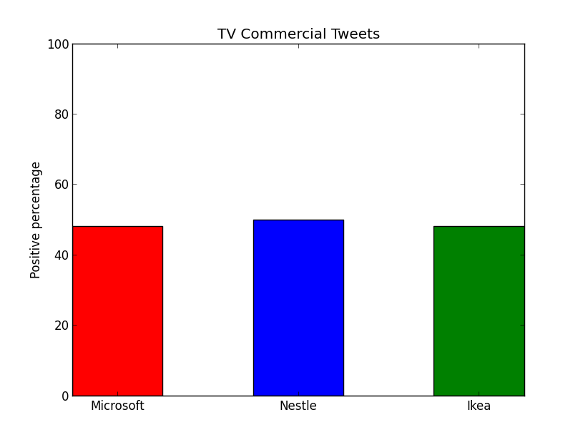

|  |  |  |  |  |
| --- | --- | --- | --- | --- |
| Tweets | Positive | Negative | Positive percentage | Total |
| Microsoft | 1583 | 1700 | 48.22% | 3283 |
| Nestle | 1862 | 1871 | 49.88% | 3733 |
| Ikea | 1325 | 1443 | 47.87% | 2768 |
| Total | **4770** | **5014** |  | **9784** |

Nestle had the most positive ratio for Tweets amongst these three companies.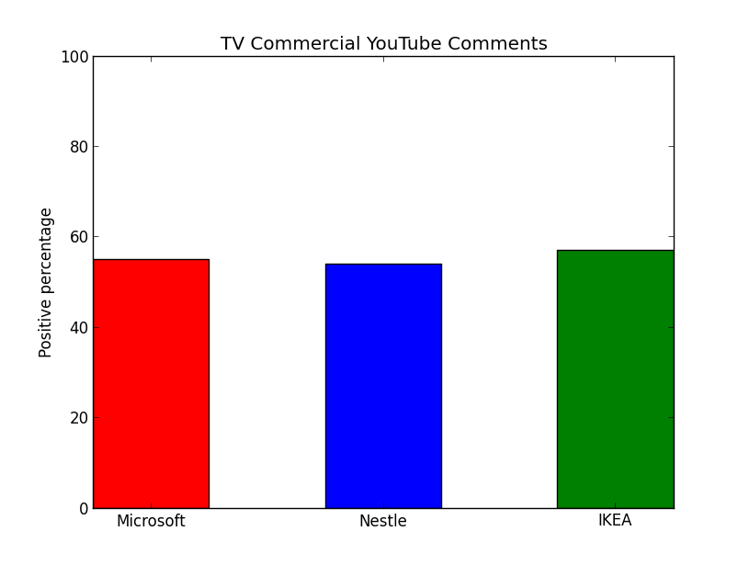

|  |  |  |  |  |
| --- | --- | --- | --- | --- |
| YouTube | Positive | Negative | Positive percentage | Total |
| Mirosoft | 3222 | 2635 | 55.01% | 5857 |
| Nestle | 373 | 313 | 54.37% | 686 |
| Ikea | 592 | 443 | 57.20% | 1035 |
| Total | **4187** | **3391** |  | **7578** |

IKEA had the most positive ratio for YouTube comments amongst these three companies.

## Super Bowl Sentiments

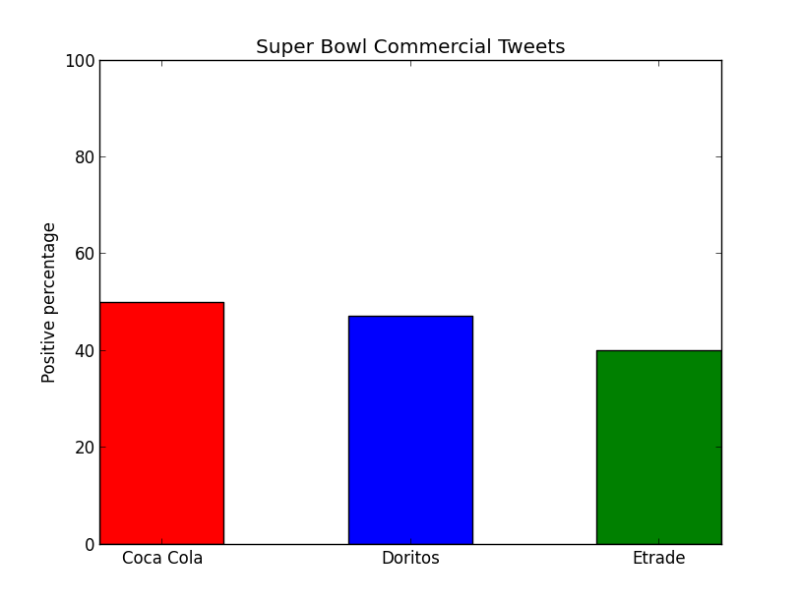

|  |  |  |  |  |
| --- | --- | --- | --- | --- |
| Tweets | Positive | Negative | Positive percentage | Total |
| Coca Cola | 1511 | 1518 | 49.88% | 3029 |
| Doritos | 1234 | 1394 | 46.96% | 2628 |
| E*TRADE | 807 | 1235 | 39.52% | 2042 |
| Total | **3552** | **4147** |  | **7699** |

CocaCola had the most positive ratio for Tweets amongst these three companies.

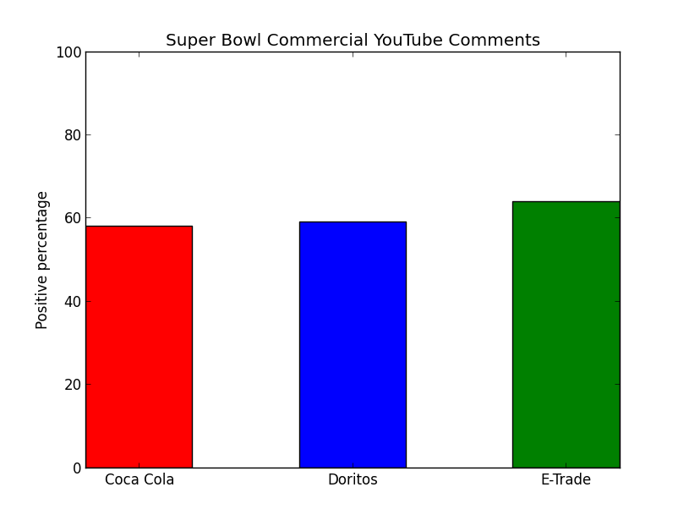

E*TRADE had the most positive ratio for YouTube comments amongst these three companies.

|  |  |  |  |  |
| --- | --- | --- | --- | --- |
| YouTube | Positive | Negative | Positive percentage | Total |
| Coca Cola | 505 | 366 | 57.98% | 871 |
| Doritos | 1695 | 1178 | 59.00% | 2873 |
| E*TRADE | 14 | 8 | 63.64% | 22 |
| Total | **2214** | **1552** |  | **3766** |

## Viral Sentiments

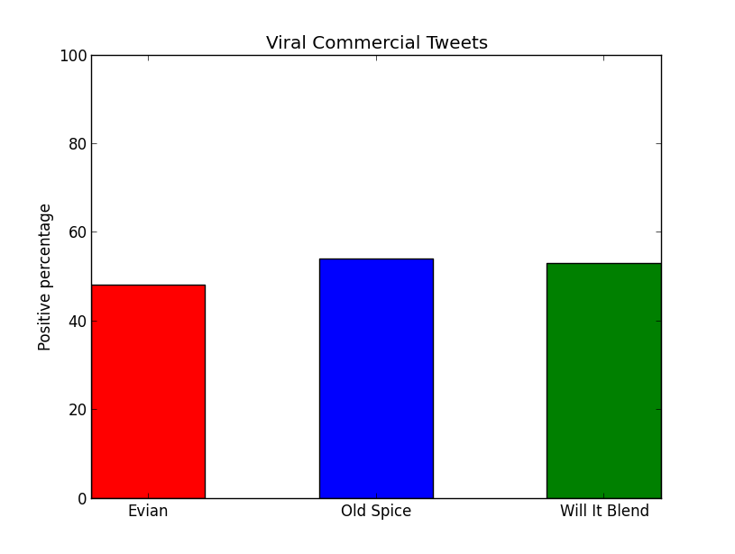

|  |  |  |  |  |
| --- | --- | --- | --- | --- |
| Tweets | Positive | Negative | Positive percentage | Total |
| Evian | 1080 | 1154 | 48.34% | 2234 |
| Old Spice | 1424 | 1228 | 53.70% | 2652 |
| will it blend | 3801 | 3381 | 52.92% | 7182 |
| Total | **6305** | **5763** |  | **12068** |

Old Spice had the most positive ratio for Tweets amongst these three companies.

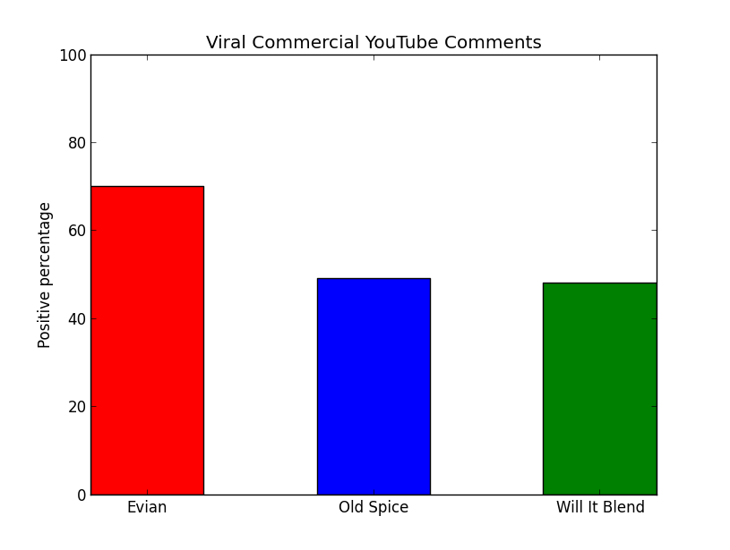

|  |  |  |  |  |
| --- | --- | --- | --- | --- |
| YouTube | Positive | Negative | Positive percentage | Total |
| Evian | 1122 | 474 | 70.30% | 1596 |
| Old Spice | 1327 | 1408 | 48.52% | 2735 |
| will it blend | 1532 | 1680 | 47.70% | 3212 |
| Total | **3981** | **3562** |  | **7543** |

Evian had the most positive ratio for YouTube comments amongst these three companies.

## Sentiment Summary

All of the advertisement methods scored fairly close to one another. 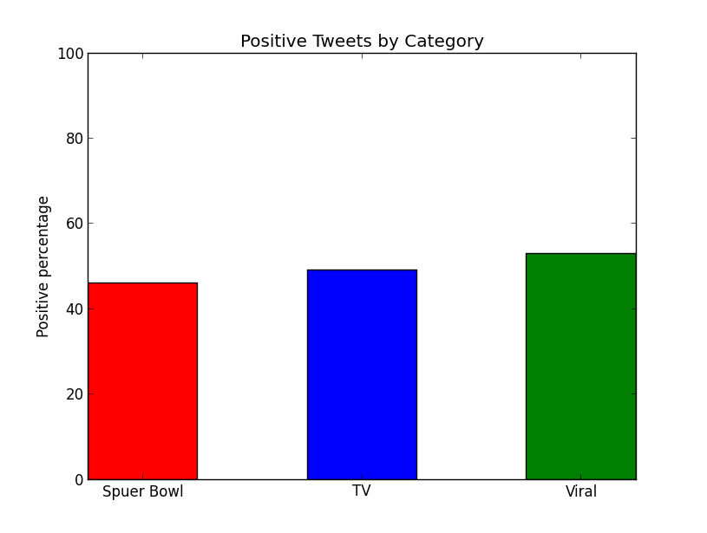

|  |  |
| --- | --- |
| Super Bowl | 46.13% |
| TV | 48.75% |
| Viral | 52.24% |

Viral is the clear winner with over 52%.

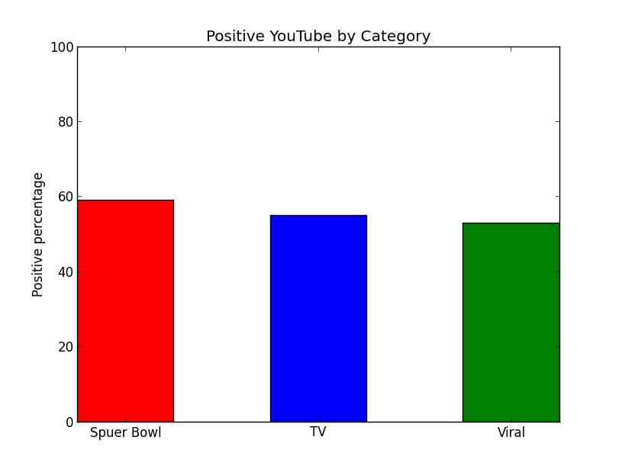

|  |  |
| --- | --- |
| Super Bowl - | 58.78% |
| TV - | 55.22% |
| Viral - | 52.77% |

Super Bowl is the obvious winner, garnering nearly 59%.

## Viewership Totals

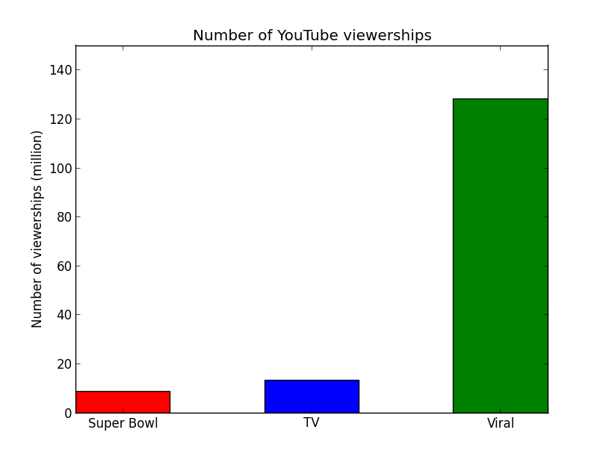

Total Viewership totals were as follows:

|  |  |
| --- | --- |
| Super bowl | 8,721,649 |
| TV | 13,123,285 |
| Viral | 132,000,000 |

Viral viewership obliterates the others with 132 million views.

# Findings & Recommendations

Analysis on sentiments can be misleading, as the creditability of sentiments is hard to determine and many Tweets and\or comments are meaningless. However, our analysis revealed that a viral campaign can increase the amount of positive perception in the Twittersphere and the sheer amount of YouTube views is undisputable and undoubtedly improves brand awareness. With sales for Old Spice body wash up over 107% for the year of its campaign and Will it Blend’s sales up over 700% after the introduction of its web advertisement series it is clear that web based advertising is the way of the future.

Of the three methods reviewed in this analysis, it is clear that a viral campaign is very cost effective. As the ‘Will it Blend’ example points out just a couple of simple props, an interesting and funny campaign can lead to a huge increase in sales and overall brand awareness. It is also important to keep the viewers engaged with the company and product. Blendtec (‘Will it Blend’) regularly tweets recipes and welcomes customers to share their recipes and kitchen experiences. Old Spice producers asked viewers for feedback on the web and viewers were glad to interact and send in their ideas for new commercials.

In conclusion, our recommendation to the executive board will be to use a Viral method of advertising.

## Tweet Traffic vs. Stock Price Correlation

We wanted to determine if there was any correlation between tweet traffic and stock fluctuation for a total of 11 points in time before and after the launch of an advertising campaign. We selected two advertisements, Doritos and OldSpice . Doritos is owned by Pepsi (PEP) and OldSpice by Proctor and Gamble (PG). Using Python we scrapped the Yahoo finance site to obtain closing stock prices. To obtain the number of Tweets per day we used Topsy’s advanced search features and selected the respective date and entered the product name as the keyword. Subsequently, we plotted the data points in the charts below. Unfortunately, the plotting was not done in Python but in Excel. Stocks fluctuate for a variety of reasons, but It is clear that on the days following the launch of these two advertising campaigns stock prices also increased.

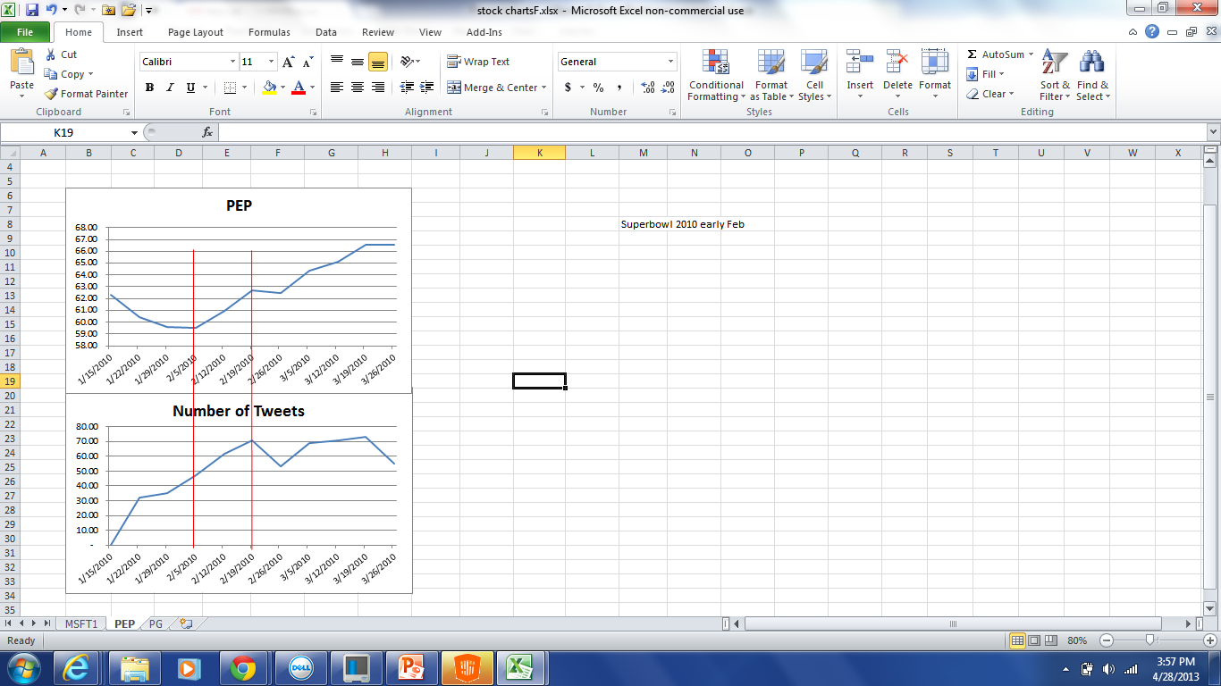

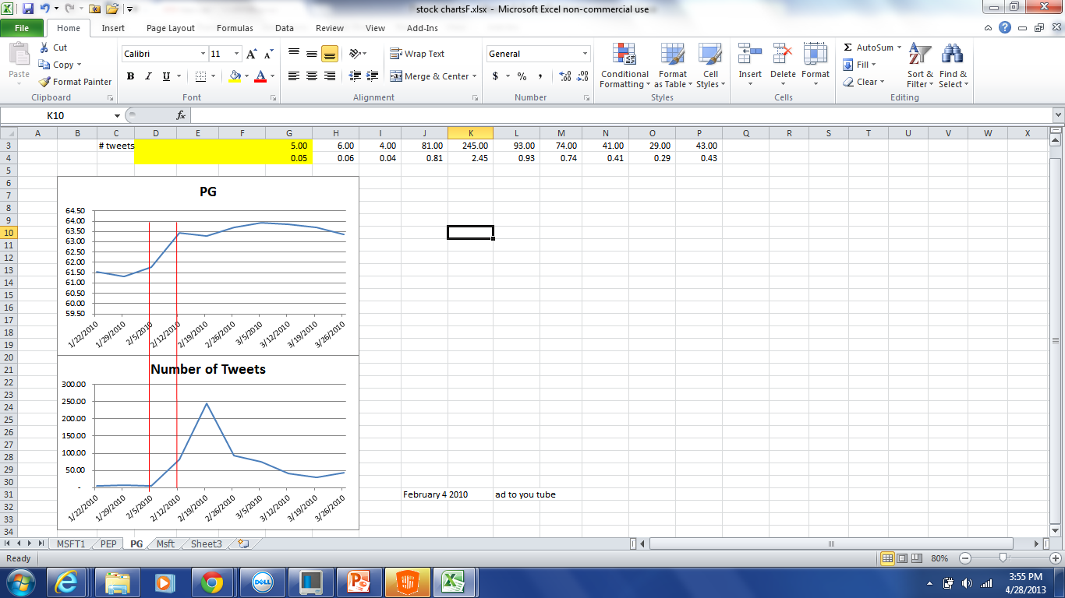

# Miscellaneous

## About the website

The webpage was created by HTML and CSS. The home page has four parts which are Super Bowl commercial, TV broadcasting commercial, Viral commercial and Tweets vs. Stock price. Click on the picture in each part and it will link to the analysis diagram and the videos for our respective advertisements.

# References

Topsy.com, source of Tweets

YouTube.com, source of comments

Dive into Python, Mark Pilgrim, http://diveintopython.org

Beginning Python from Novice to Professional, Magnus Lie Hetland

An Introduction to Text Analysis with Python, Parts 1 through 3, Neal Caren, [http://nealcaren.viral.unc.edu/an-introduction-to-text-analysis-with-python](http://nealcaren.web.unc.edu/an-introduction-to-text-analysis-with-python)

|  |
| --- |
| [www.superbowl-commercials.org/17911.html](http://www.superbowl-commercials.org/17911.html)  <http://superbowl-ads.com/> |
| <http://www.acemetrix.com/> |
| [http://www.nbcnews.com](http://www.nbcnews.com/) |
| [http://www.businessinsider.com](http://www.businessinsider.com/)  <http://mashable.com/2007/09/27/blendtec-sales/>  http://www.reelseo.com/ad-age-publishes-top-10-viral-video-ads-time/ |
| <http://www.internetretailer.com/2011/12/21/blendtec-shows-how-measure-effects-social-marketing>  <http://www.whatsnextblog.com/2010/06/blendtec_reaches_new_comic_viral_production_heights_with_iphone_4_will_it_b/>  <http://mashable.com/2010/07/15/old-spice-stats/>  [http://www.prviral.com/releases/new-old-spice/commercial-parody/prviral5190364.htm](http://www.prweb.com/releases/new-old-spice/commercial-parody/prweb5190364.htm)  <http://www.pg.com/en_US/downloads/innovation/factsheet_OldSpice.pdf>  <http://www.inc.com/articles/201108/5-marketing-lessons-from-old-spice.html> |
|  |

Code Description (as seen in our Github folder)

|  |  |  |
| --- | --- | --- |
| # | **Code** | **Contents** |
| **1** | Barchart | used to plot our charts |
| **2** | BIA660-final.rar | Viral page coding |
| **3** | cleaning_validating_Algorithm | used within Topsy Analysis to clean and validate tweets |
| **4** | frame2 | used to apply positive and negative sentiment to YouTube comments |
| **5** | Neg * | used this table of positive words to conduct the sentiment analysis. |
| **6** | Posi * | used this table of negative words to conduct the sentiment analysis. |
| **7** | StockScraping | used to obtain historical stock quotes from Yahoo Finance |
| **8** | Topsy Analysis | used to extract tweets from Topsy & apply positive & negative analysis |
| **9** | YouTube Analysis | used to extract comments from YouTube |
| **10** | YouTube Cleanup | used to clean and validate comments extracted from YouTube |
| **11** | YouTube_view counts | used to collect number of YouTube views |

* Lists obtained from: An Introduction to Text Analysis with Python, Parts 1 through 3, Neal Caren, [http://nealcaren.viral.unc.edu/an-introduction-to-text-analysis-with-python](http://nealcaren.web.unc.edu/an-introduction-to-text-analysis-with-python)